Planning

|  |
| --- |
| **System Request – WooleyWorld Website** |
| Client:WooleyWorld |
| Needs:Give a consistent place for users to access media and information from WooleyWorld on the web. |
| Requirements:   * Page to welcome the user. * Page where people can watch animations. * Page where people can look at art. * Page where people can see what the company is and where else to find it. * Way to manage content without code. |
| Special constrains:   * Needs to work on mobile. |

# Feasibility

## Technical:

Familiarity with application:

Knowledgeable of applications of websites and basic needs of media sharing. Have years of experience with the content creator and understand needs.

Familiarity with technology:

Have experience with html5, JavaScript, CSS, and general object-oriented programming. Only familiar with ASP webforms on the IIS platform. Adobe Animate will be used for some interactive front-end content. I am unfamiliar with the html5 canvas and the createjs library that will be used for this. Familiar with git for source control.

## Economic:

Operating costs:

This will vary based on the decided method of hosting. Options are to host through cloud services or from a machine on a home internet connection. In the home case, the costs will be the building of the machine and electricity to run it as well as upgrading hardware in the future. One of these will be chosen depending on the requirements of delivering the content and traffic of the website. Cloud hosting could be anywhere between $5-$60/month, but this would be coverable as well as dns costs if the service doesn’t come with it.

Analysis

# Requirements Analysis

## Banner across the top of every page for consistent navigation:

Processes:

* Not too big so the rest of the viewport can be filled with the animated elements for the rest of the page
* Logo
* Links to other pages
  + Animations
  + Gallery
  + Where to find us
    - Links to Facebook, Newgrounds, DeviantArt, Twitter, Tumblr pages
  + About us

## Page to welcome the user:

Processes:

* Viewport filled with interactive html5 canvas with buttons that lead to other pages on the site
  + Animations
  + Gallery
  + Where to find us
  + About us
  + Section for natural born suckers

## Page where people can see what the company is and where else to find it:

Processes:

* Images to represent the WooleyWorld members
* Contact details
* Sections for biographies or anything the members to write down about them

## Page where people can watch animations:

Processes:

* This is where the full-length animations will be accessed from
* All animations shown at once
* Sections organized by release year
* Top of the page will have a featured animations section
  + individually selected animations
  + Include title, description, and thumbnail
* link underneath features to the natural born suckers series page
* Animations can be grouped into a series, but don’t have to be
* Series and individual animations can have a fully customized page with animated elements
* Generic page for animations that don’t need customization
  + Share buttons for social media
    - Thumbnails and information for links on social media
    - Facebook
    - Tumblr
    - Twitter
* Animations in a series don’t have their own animation page for playback, rather they play in the series page with a unique URL
  + Each animations unique URL in a series page would need its own share buttons for social media
    - Thumbnails and information for links on social media
    - Facebook
    - Tumblr
    - Twitter
* Search bar for title

Information:

* Animations have a thumbnail, title, description, and upload date
* Animations can be a feature
* Animations can be in a series
* Series have a title, description, and thumbnail

## Page where people can look at art:

Processes:

* “Art” is everything besides the full-length animations
* Page defaults to showing everything independent of category or tag
* Main categories depending on the type of art
  + Stills
  + Gifs
  + Sketches
* Each piece of art can have as many tags as wanted to identify it
* Option to go to a specific category or tag
* Option to view all tags and sort them by title or number of entries
* Search bar for title or tag
* Each artwork has its own page that expands without leaving the gallery
  + Shows basic information like title, description, date posted
  + Share buttons for social media
    - Thumbnails and information for links on social media
    - Facebook
    - Tumblr
    - Twitter

Information:

* Artwork needs to be a gif/still/sketch
* Artwork can have one or more tags
* Tags need a title
* Artwork needs to have a title, description, upload date, and thumbnail

## Content Management System:

Processes:

* Authenticate administrators
* Add new artwork or animation
* Edit artwork or animation information
* Remove artwork or animation
* Featured animations management
* Animation series management

Information:

* Administrator account information
* Artwork title, description, upload date, thumbnail
* Artwork tags
* Artwork type(gif/still/sketch)
* Animation thumbnail, title, description, and upload date
* Animation can be a feature
* Animation can be in series

# Use Cases

## Content Management System

|  |  |
| --- | --- |
| **Title:** Add new animation | **ID:** A-1 |
| Actor: Administrator | |
| Description: Administrator enters information for a new animation and the new entity is created in the animation datastore. | |
| Trigger: Administrator wants to add an animation to the website. | |
| Type: External | |
| Preconditions:   1. Administrator is authenticated 2. Administrator is on the content management page | |
| Normal Course:   1. Admin presses add new animation button. 2. Admin enters animation information and submits. 3. System creates new entity in animation datastore. | |
| Exceptions:   1. Admin cancels creation. | |

|  |  |
| --- | --- |
| **Title:** Add new artwork | **ID:** A-2 |
| Actor: Administrator | |
| Description: Administrator enters information for new artwork and the new entity is created in the artwork datastore. | |
| Trigger: Administrator wants to add artwork to the website. | |
| Type: External | |
| Preconditions:   1. Administrator is authenticated 2. Administrator is on the content management page | |
| Normal Course:   1. Admin presses new artwork button. 2. Admin specifies whether the artwork is gif/still/sketch. 3. Admin specifies what tags the artwork is under. 4. Admin enters artwork information and submits. 5. System uploads artwork from admin pc to server. 6. System creates new entity in artwork datastore. | |
| Exceptions:   1. Admin cancels creation. | |

|  |  |
| --- | --- |
| **Title:** Edit animation/artwork | **ID:** A-3 |
| Actor: Administrator | |
| Description: Administrator changes animation/artwork information and the entity is updated in the relevant datastore. | |
| Trigger: Administrator wants to change animation/artwork information. | |
| Type: External | |
| Preconditions:   1. Administrator is authenticated 2. Administrator is on the content management page | |
| Normal Course:   1. Admin presses edit button on the animation/artwork tile. 2. System shows animation/artwork information. 3. Admin modifies animation/artwork information and submits. 4. System updates entity in relevant datastore. | |
| Exceptions:   1. Admin cancels modification. | |

|  |  |
| --- | --- |
| **Title:** Remove animation/artwork | **ID:** A-4 |
| Actor: Administrator | |
| Description: Administrator removes animation/artwork and the entity is removed from the relevant datastore. | |
| Trigger: Administrator wants to remove animation/artwork. | |
| Type: External | |
| Preconditions:   1. Admin is authenticated 2. Admin is on the content management page | |
| Normal Course:   1. Admin presses delete button on the animation/artwork tile. 2. System asks to verify deletion. 3. Admin confirms deletion. 4. System removes entity from relevant datastore. | |

|  |  |
| --- | --- |
| **Title:** Create new animation series | **ID:** A-5 |
| Actor: Administrator | |
| Description: Administrator creates a new series and the new entity is created in the series datastore. | |
| Trigger: Administrator wants to create a new series | |
| Type: External | |
| Preconditions:   1. Administrator is authenticated 2. Administrator is on the content management page | |
| Normal Course:   1. Admin expands the series section. 2. System shows all series. 3. Admin presses add new series button. 4. Admin fills out series information. 5. Admin drags and drops the animation onto the “animations in series” section. 6. Admin submits the new series. 7. System creates new series entity in content datastore. | |
| Exceptions:   1. Admin cancels series creation. | |

|  |  |
| --- | --- |
| **Title:** Removeanimation series | **ID:** A-6 |
| Actor: Administrator | |
| Description: Administrator removes a series and the entity is removed from the series datastore. | |
| Trigger: Administrator wants to remove a series | |
| Type: External | |
| Preconditions:   1. Administrator is authenticated 2. Administrator is on the content management page | |
| Normal Course:   1. Admin expands the series management section. 2. System shows all series. 3. Admin presses delete button on series tile. 4. System asks to verify deletion. 5. Admin confirms deletion. 6. System removes entity from content datastore. | |

|  |  |
| --- | --- |
| **Title:** Edit animation series | **ID:** A-7 |
| Actor: Administrator | |
| Description: Administrator changes series information and the series entity is updated in the series datastore. | |
| Trigger: Administrator wants to change series information. | |
| Type: External | |
| Preconditions:   1. Administrator is authenticated 2. Administrator is on the content management page | |
| Normal Course:   1. Admin expands the series management section. 2. System shows all series. 3. Admin presses edit button on series tile. 4. System shows series information and animations in series 5. Admin modifies series information. 6. (See Alternative Course 1.e.1 or 1.e.2) 7. Admin submits information. 8. System updates entity in series datastore. | |
| Alternative Course:  1.e.1 Admin presses remove from series button and animation is removed from the series.  1.e.2 Admin drags and drops an animation onto the “animations in series” section. | |
| Exceptions:   1. Admin cancels modification. | |

|  |  |
| --- | --- |
| **Title:** Add featured animation | **ID:** A-8 |
| Actor: Administrator | |
| Description: Administrator adds an animation to the featured animations and an entity is created in the feature datastore. | |
| Trigger: Administrator wants to add a featured animation. | |
| Type: External | |
| Preconditions:   1. Administrator is authenticated 2. Administrator is on the content management page | |
| Normal Course:   1. Admin expands the featured animations section. 2. System shows all features. 3. Admin drags and drops an animation onto the features section. 4. System creates entity in feature datastore. | |

|  |  |
| --- | --- |
| **Title:** Remove featured animation | **ID:** A-9 |
| Actor: Administrator | |
| Description: Administrator removes an animation from the featured animations and the entity is removed from the feature datastore. | |
| Trigger: Administrator wants to remove a featured animation. | |
| Type: External | |
| Preconditions:   1. Administrator is authenticated 2. Administrator is on the content management page | |
| Normal Course:   1. Admin expands the featured animations section. 2. System shows all current features. 3. Admin presses delete button on featured animation tile. 4. System removes the entity from the feature datastore. | |

# Data Flow Diagram

## Content Management System

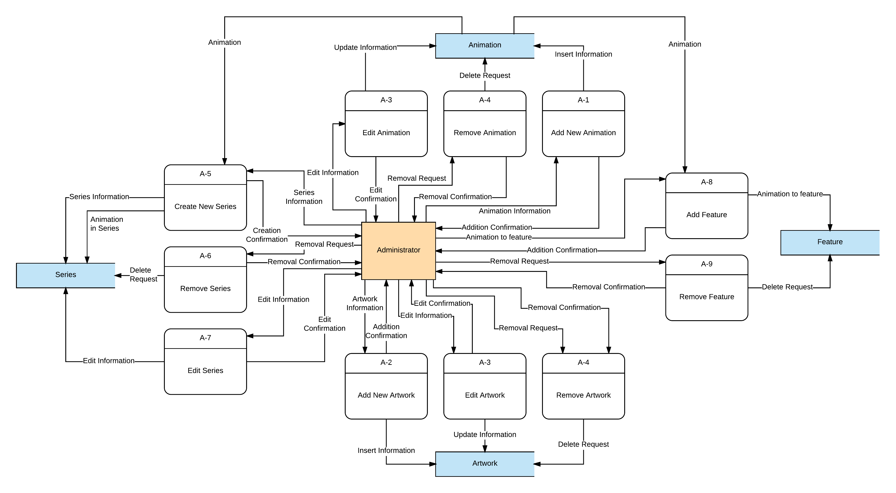

## Web Pages

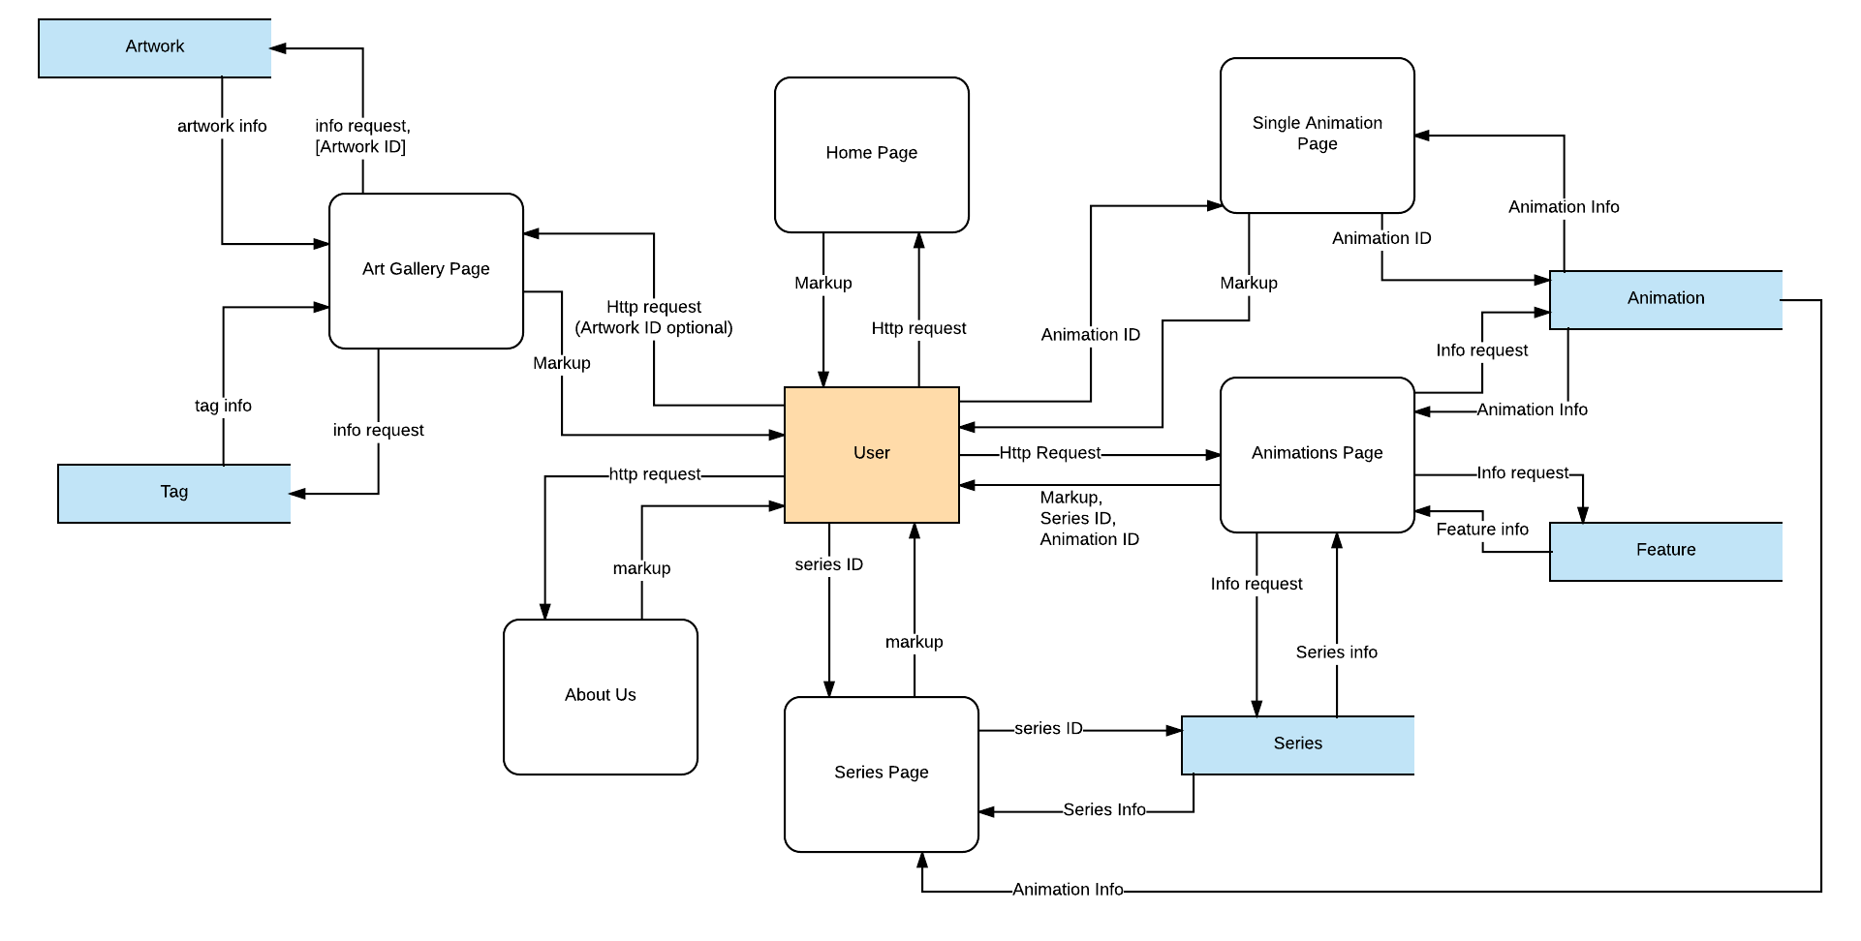

# Entity Relationship Diagram

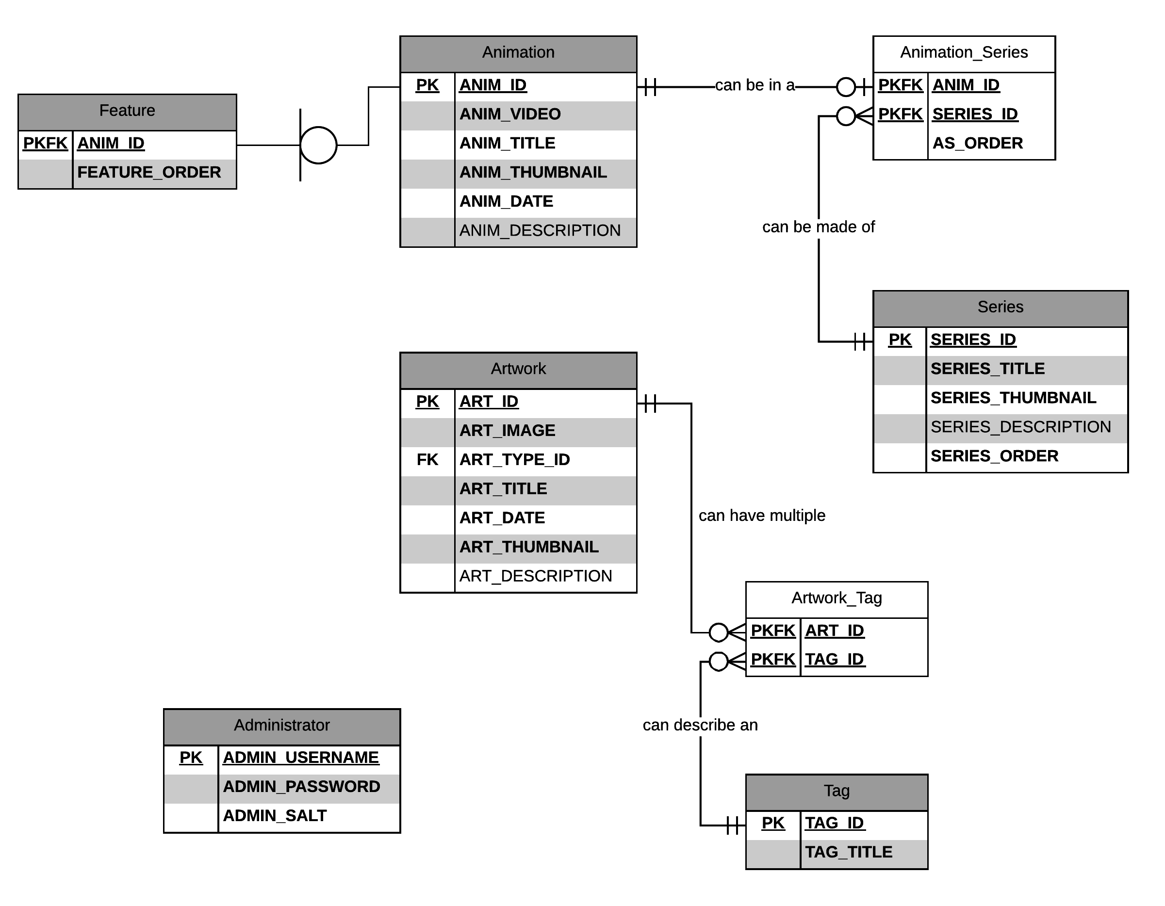

# Data Dictionary

|  |  |  |
| --- | --- | --- |
| Field | Description | Datatype |
| ADMIN\_PASSWORD | Password for an admin account. It is encrypted. | NCHAR(256) |
| ADMIN\_SALT | Randomly generated string that was prepended to the password before being encrypted. | NCHAR(256) |
| ADMIN\_USERNAME | Username an admin uses to log in. | NVARCHAR(20) |
| ANIM\_DATE | Date the animation was added. | DATE |
| ANIM\_DESCRIPTION | Written description for an animation. | NVARCHAR(MAX) |
| ANIM\_ID | Unique number used to identify an animation. | INT AUTO INCREMENT |
| ANIM\_THUMBNAIL | Path to 200x113 image used in an animation tile. Image is generated by CMS. | NVARCHAR(50) |
| ANIM\_TITLE | Title of an animation. | NVARCHAR(50) |
| ANIM\_VIDEO | Youtube ID of the animation. | NVARCHAR(20) |
| ART\_DATE | Date the artwork was added. | DATE |
| ART\_DESCRIPTION | Written description for an artwork. | NVARCHAR(MAX) |
| ART\_ID | Unique number used to identify an artwork. | INT AUTO INCREMENT |
| ART\_IMAGE | Path to image of the artwork. | NVARCHAR(50) |
| ART\_THUMBNAIL | Path to 200x113 image used in an artwork tile. | NVARCHAR(50) |
| ART\_TITLE | Title of the artwork. | NVARCHAR(50) |
| ART\_TYPE | Type of artwork. The types of artwork are GIF, Sketch, and Still. | NVARCHAR(6) |
| AS\_ORDER | The place, in order, an animation will be shown on the series page. | INT |
| FEATURE\_ORDER | The place, in order, a feature will be shown in the features section. | INT |
| SERIES\_DESCRIPTION | Written description for a series. | NVARCHAR(MAX) |
| SERIES\_ID | Unique number used to identify the series. | INT AUTO INCREMENT |
| SERIES\_THUMBNAIL | Path to 200x113 image used in a series tile. | NVARCHAR(50) |
| SERIES\_TITLE | Title of a series. | NVARCHAR(50) |
| SERIES\_ORDER | The place, in order, a series will be shown on the animations page. |  |
| TAG\_ID | Unique number used to identify the tag. | INT AUTO INCREMENT |
| TAG\_TITLE | Title of a tag. | NVARCHAR(50) |

Design

# Architecture Design

Client

* Web browser
* CreateJS (Made with Adobe Animate)

Server

* Platform
  + Asp.net MVC
  + IIS
* Data Storage
  + SQL server database
  + Video media hosted through YouTube
  + Image media stored on filesystem
* Hosting
  + Cloud hosted

# CRUD Matrix

|  |  |  |  |  |  |  |  |  |
| --- | --- | --- | --- | --- | --- | --- | --- | --- |
|  | URL | GET | POST | PUT | DELETE | | Comments | |
| 1 | **/administrators** | ✔ | ✔ |  | |  | |  |
| 2 | **/administrators/{Admin\_Username}** |  |  |  | | ✔ | |  |
| 3 | **/animations** | ✔ | ✔ |  | |  | |  |
| 4 | **/animations/{Anim\_ID}** | ✔ |  | ✔ | | ✔ | |  |
| 5 | **/animations/random?quantity={n}** | ✔ |  |  | |  | | Returns n number of randomly selected animations |
| 6 | **/artworks** | ✔ | ✔ |  | |  | |  |
| 7 | **/artworks/{Art\_ID}** | ✔ |  | ✔ | | ✔ | |  |
| 8 | **/features** | ✔ |  | ✔ | |  | |  |
| 9 | **/series** | ✔ | ✔ | ✔ | |  | |  |
| 10 | **/series/{Series\_ID}** | ✔ |  | ✔ | | ✔ | |  |
| 11 | **/thumbs/animations||artworks/{type}** | ✔ |  |  | |  | | Only returns ID, title, date, and thumbnail of items. Type applies to artworks |

# Interface Design

## CMS

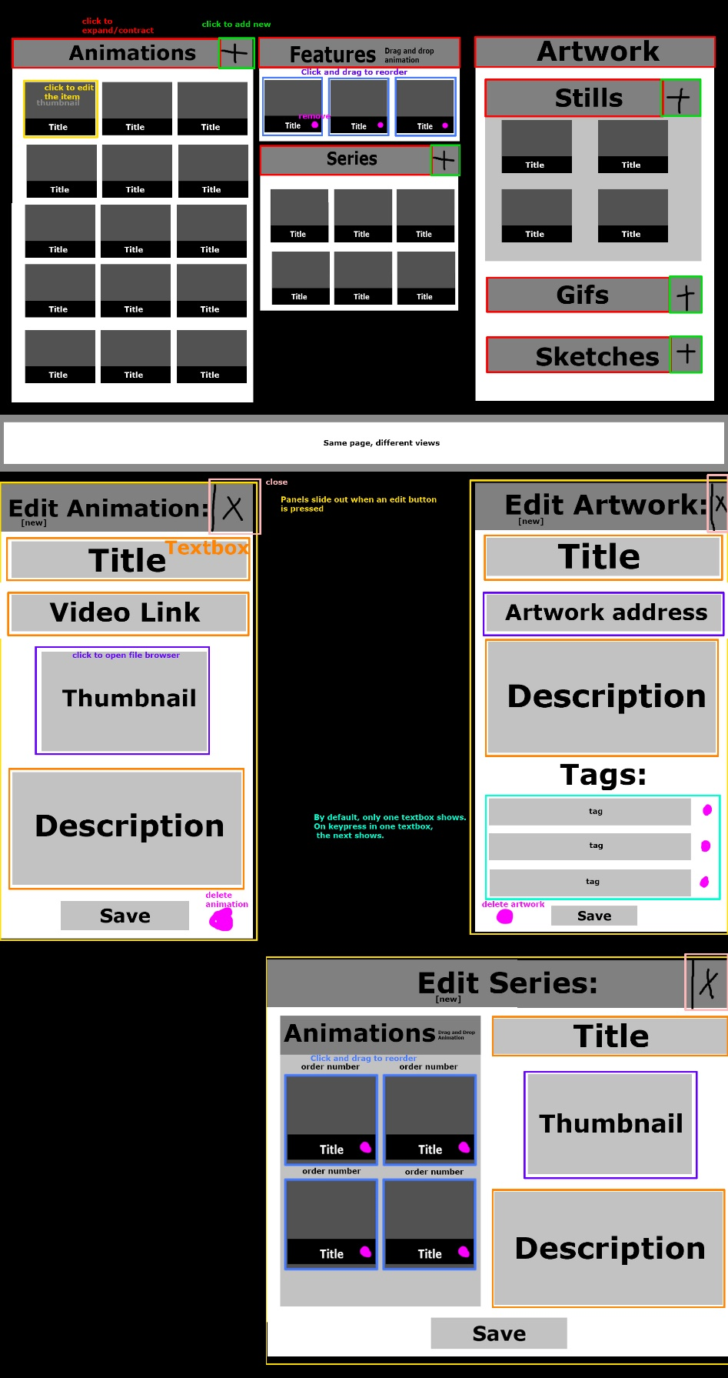

## Banner

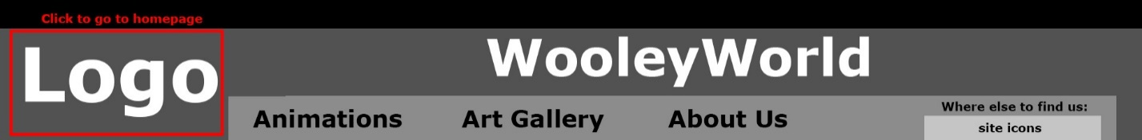

## AnimationsC:\Users\FBI_Moped_6969\AppData\Local\Microsoft\Windows\INetCache\Content.Word\animations.jpg

## Single Animation Page

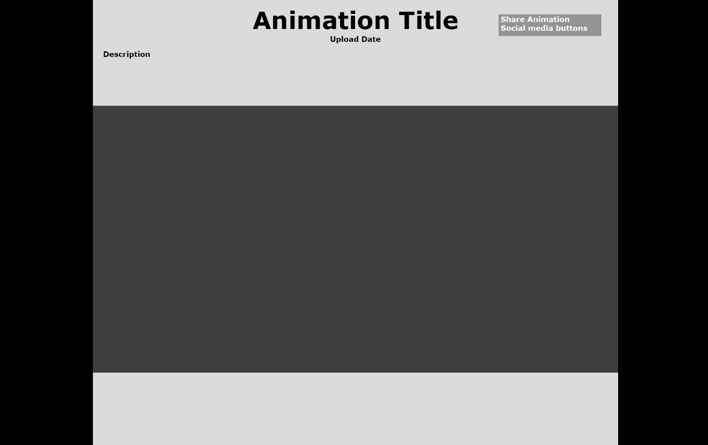

## Series Page

## C:\Users\FBI_Moped_6969\AppData\Local\Microsoft\Windows\INetCache\Content.Word\series generic.jpg

## Art Gallery

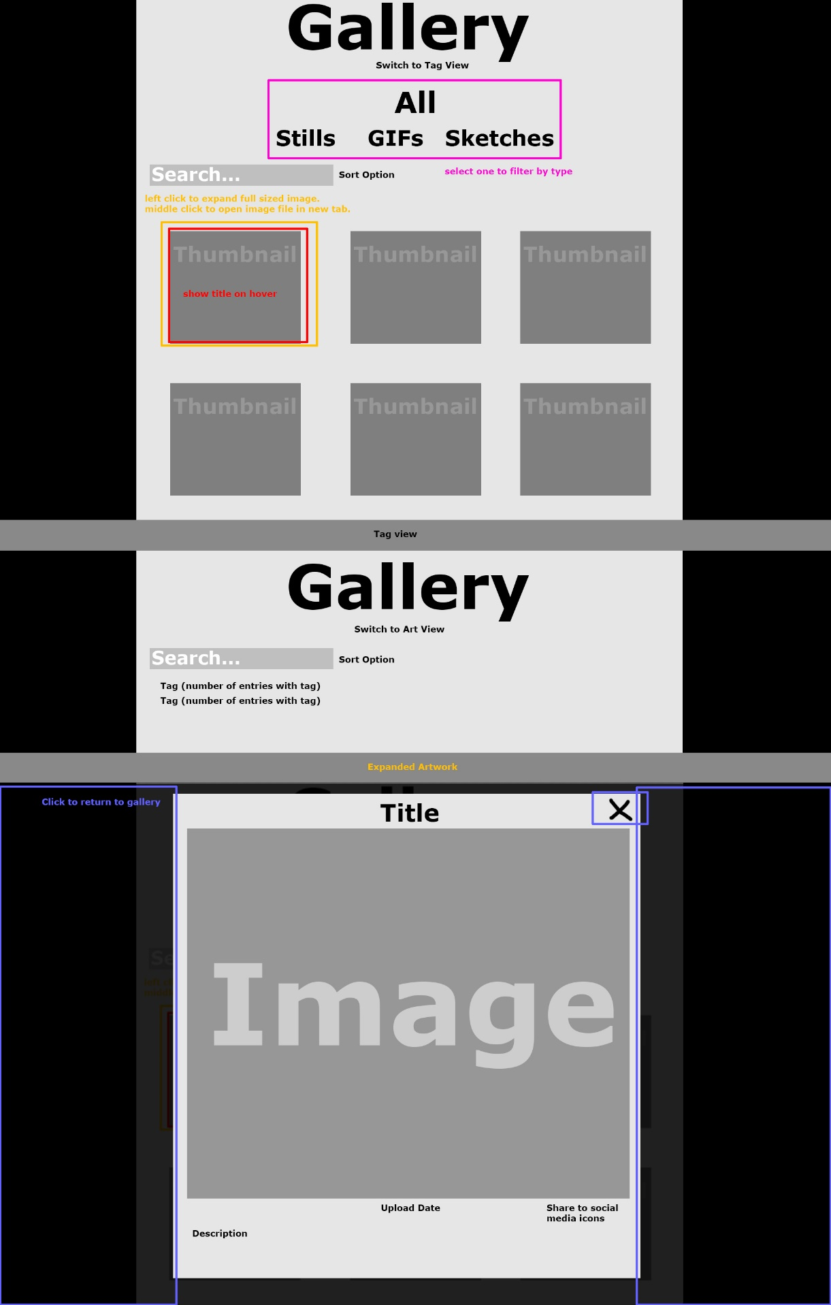

## About Us

